[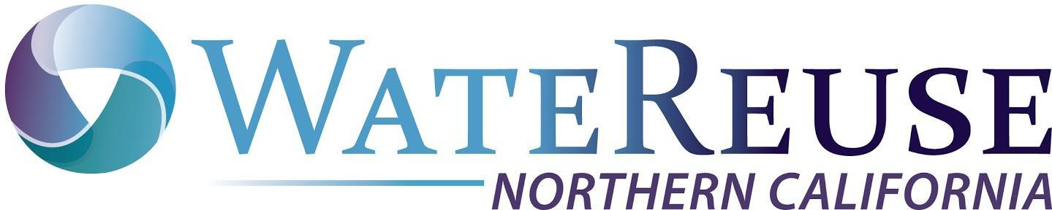](https://watereuse.org/sections/watereuse-california/chapters/northern-california-chapter/)WateReuse_CA_CVSF_rgb_compressed

|  |  |
| --- | --- |
| **WateReuse Association**  **Joint Meeting Northern California & Central Valley Chapters**  **Friday, August 16, 2024 – 8:30 am to 1:00 pm**  **Location:** Central San (Multipurpose Room) 5019 Imhoff Place, Martinez, CA 94553  **Zoom Meeting ID**: 840 0500 5879 Passcode: 724280 | |
| **Reuse Successes and Lessons Learned in the Central Valley & Northern California** | |
| **8:30 – 9:00 am** | **Coffee & Breakfast– Sponsored by Carollo & Jacobs** |
| **9:00 – 9:05 am** | **Welcome/Introductions**  Ted Couch, President, Northern California Chapter of WateReuse |
| **9:05 – 9:15 am** | **Central San Welcome**  Roger Bailey, General Manager Central Contra Costa Sanitary District |
| **9:15 – 9:40 am** | **Central San & EBMUD Recycled Water Feasibility Study**  Sarah Reynolds, Associate Engineer, EBMUD |
| **9:40 – 9:50 am** | **Agricultural Reuse Committee Update**  Melanie Holmer, Jacobs |
| **9:50 – 10:20 am** | **Coffee & Networking Break** |
| **10:20 – 11:00** | **Recycled Water Drivers and Lessons Learned Panel**  Rhodora Biagtan (Moderator), Melody LaBella (Central San), Jennifer Burke (City of Santa Rosa), Tracy Crane (EID), Pedro Hernandez (SBWR), Gayleen Darting (Sac Sewer) |
| **11:00 -11:20 am** | **Leg/Reg Update**  Brenley McKenna, Managing Director WateReuse California |
| **11:20 – 11:25 am** | **Closing Remarks**  Ted Couch, President, Northern California Chapter of WateReuse |
| **11:25 – 11:50 pm** | **Lunch – Sponsored by Carollo & Jacobs** |
| **11:50– 1:00 pm** | **Coco Sustainability Farms & Tour** by Dr. Carolyn Phinney |

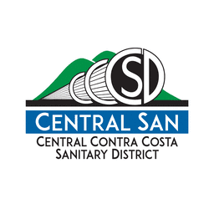**

**Speaker Biographies:**

**Sarah Reynolds** is an associate engineer in the East Bay Municipal Utility District (EBMUD) Office of Water Recycling, where she is the project manager for two existing industrial recycled water projects and develops planning studies to assess opportunities for expansion of EBMUD’s recycled water program. In her seven years with EBMUD, Sarah has also gained experience in water distribution planning, process engineering, and water rights. Prior to joining EBMUD, Sarah worked at AECOM on water and wastewater planning projects for public agency clients in the Bay Area.

**Melanie Holmer** is a Global Reuse Principal at Jacobs and has over 25 years of experience in water, wastewater and water reuse planning, design and construction. She is the Central Valley/Sierra Foothills Chapter Trustee on the WateReuse CA Board and the Co-Chair of the WRCA Ag Reuse Committee.

**Rhodora N. Biagta**n is with West Yost and specializes in master planning, recycled water program planning and implementation, water conservation, and project management. She has 29 years of experience in the water and wastewater industry, including almost 24 years working in a public utilities district that provided potable water, recycled water, and wastewater services. She has managed water resources and utilities planning, development services, permitting, recycled water program, water conservation, and capital improvement projects. She has experience working in collaborative relationships with other agencies and organizations. She has been an active member of WateReuse, served on the Northern California Chapter Board from 2010 to 2020.

**Melody LaBella** is the Resource Recovery Program Manager for Central Contra Costa Sanitary District (Central San), where she’s worked for nearly 23 years.  Melody’s work experience has included a focus on preventing wastewater pollution at its source, developing and implementing recycled water projects and programs, implementing sustainable practices, and helping to shape and develop regulations, legislation, and policies in support of Central San's mission to protect public health and the environment.  Melody received a BS degree in Environmental Engineering from Penn State University and is a registered professional Civil Engineer in California.  Melody is also the current Vice President of the WateReuse Northern California Chapter.

**Jennifer Burke** is the Director of Santa Rosa Water, responsible for overseeing the water delivery, wastewater collection, and stormwater management for the City of Santa Rosa, as well as the wastewater treatment and reuse for Santa Rosa and three surrounding communities. She has worked for the Water Department since 2003 and has been the Water Director since May 2019.  Prior to working for the City of Santa Rosa, she worked for the City of San Jose on the regional South Bay Water Recycling Program. She has a Bachelor’s degree in environmental studies from U.C. Santa Barbara and a Master’s in Business Administration from San Jose State University.

**Tracy Crane** has more than 30 years of experience in the wastewater field. For a significant part of his career, he served the citizens of Meridian, Idaho, and played a crucial role in developing Idaho’s first Municipal Recycled Water program. Currently, he works as the Wastewater/Recycled Water Operation Manager at El Dorado Irrigation District (EID). Tracy holds a Grade V California Wastewater Treatment Plant Operator’s Certificate, Grade IV licenses for both Wastewater Treatment and Collections issued by the state of Idaho, and an Idaho Grade III Laboratory Analyst Certification.

**Pedro Hernandez** has worked in the utility industry for over 15 years, including for the United States Department of Interior Office of Environmental Policy & Compliance, Region IX.  His experience in the water industry extends nearly as long. He currently oversees the South Bay Water Recycling Program, for which he previously interned, and will oversee the City of San Jose’s Purified Water Program. In 2018, Pedro was selected as “Staff Person of the Year” for the WateReuse California Annual Conference.  Mr. Hernandez previously served as the WateReuse Northern California Chapter President and is currently the Chapter representative to the California WateReuse Board of Trustees.

**Gayleen** **Darting** is an Associate Civil Engineer and Project Manager with the Sacramento Area Sewer District. She has over 18 years of experience working with sewer agencies, focusing on water recycling for the last 10 years. Before that, she worked in land development in California’s Central Valley. She earned her Bachelor of Science from the University of the Pacific in 2001 and her Civil Engineering license in 2004 from the State of California. She is a member of WateReuse and the American Society of Civil Engineers. In her free time, she enjoys Lego, gaming, and traveling.

**Brenley McKenna** has over 15 years of experience in the water sector, holding a bachelor's degree in environmental science from UC Davis and a master's degree in environmental engineering from the Colorado School of Mines. With roles at two Colorado water utilities, she managed recycled water systems and led efforts to expand water reuse regulations. For seven years at The Water Research Foundation, Brenley facilitated subscriber engagement and connected utilities to research resources. Currently, as Managing Director for WateReuse California, she champions responsible stewardship of water resources, maximizing the safe use of recycled water and supporting the WateReuse Association's initiatives.

**Dr. Carolyn Phinney** has been an active leader in Contra Costa County for the past 15 years; and is the Founder and President of AgLantis, a 501c-3 non-profit organization with a mission to create a sustainable and just community promoting food equity, environmental protection, education and economic development.  She received her  her PhD in research psychology from the University of California, Berkeley. She is the President of the nonprofit AgLantis, which she co-founded in 2014. AgLantis runs a charity 15 acre regenerative farm on Central San buffer land using Title 22 water.